**Supplementary Tables and Figures**

1. **Diet**

**1.1) Body Size**

**1.1.2)**

**1.1.3)**

**1.1.4)**

**1.2) Alpha Diversity**

**1.2.1)**

**1.2.2)**

**1.3) Beta-diversity**

**1.3.1)**

**1.4) Beta-Dispersion**

**1.4.1)**

|  |  |  |
| --- | --- | --- |
| **Bray-Curtis** | **Canberra** | **Sørensen** |
|  |  |  |

**1.5) Differential Abundance**

**1.5.1)**

1. **Diet and development**

**2.1) Body Size**

**2.1.1)**

**2.1.2) Microbiome**

**2.1.2.2) Beta Diversity**

**2.1.3) 7 mpf**

**2.1.3.1) Body Size**

**2.1.3.2) Alpha Diversity**

**2.1.3.3) Beta Diversity**

**2.1.3.4) Beta diversity**

|  |  |  |
| --- | --- | --- |
| **Bray-Curtis** | **Canberra** | **Sørensen** |
|  |  |  |

**2.2) Alpha Diversity**

**2.2.1)**

**2.2.2)**

**2.3) Beta Diversity**

**2.3.1)**

**2.3.2)**

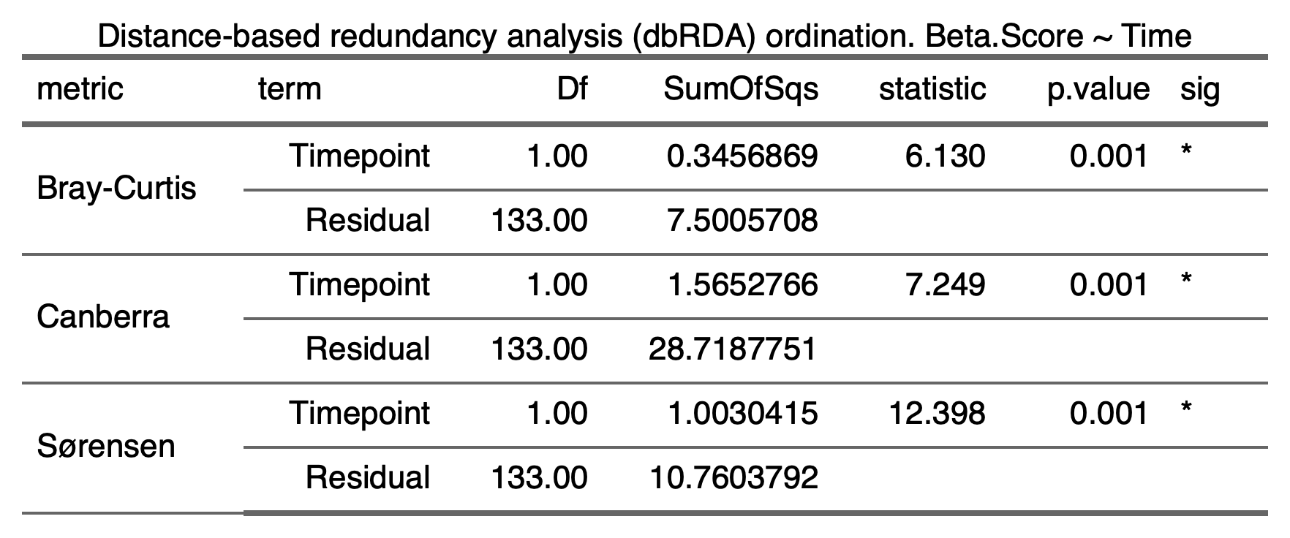

**2.4) Beta Dispersion**

**2.4.1) Diet**

**2.4.1.1) Gemma Diet**

|  |  |  |
| --- | --- | --- |
| **Bray-Curtis** | **Canberra** | **Sørensen** |
|  |  |  |

**2.4.1.2) Watts Diet**

|  |  |  |
| --- | --- | --- |
| **Bray-Curtis** | **Canberra** | **Sørensen** |
|  |  |  |

**2.4.1.3) ZIRC Diet**

|  |  |  |
| --- | --- | --- |
| **Bray-Curtis** | **Canberra** | **Sørensen** |
|  |  |  |

**2.5) Differential Abundance**

**2.5.1) All diets (4 mpf vs 7 mpf)**

**2.5.2) Gemma Diet**

**2.5.3) Watts Diet**

**2.5.4) ZIRC Diet**

1. **Pathogen Exposure**

**3.1) Histopathology**

**3.1.1) Infection Counts ~ Diet + Sex**

**Asymptotic Pearson Chi-Squared Test**

**data: Var2 by Var1 (p, n)**

**chi-squared = 11.519, df = 2, p-value = 0.003152**

**3.1.2) Infection Counts ~ Diet (Males only)**

**Asymptotic Pearson Chi-Squared Test**

**data: Var2 by Var1 (p, n)**

**chi-squared = 11.519, df = 2, p-value = 0.003152**

**3.1.3) Infection Counts ~ Diet (Males Only), microbiome sample subset**

**Asymptotic Pearson Chi-Squared Test**

**data: Var2 by Var1 (p, n)**

**chi-squared = 4.0699, df = 2, p-value = 0.1307**

**3.1.4) Body Condition Score ~ Diet*Infection Counts**

**3.1.5) Alpha Diversity**

**3.1.6) Beta Diversity**

**3.1.2)**

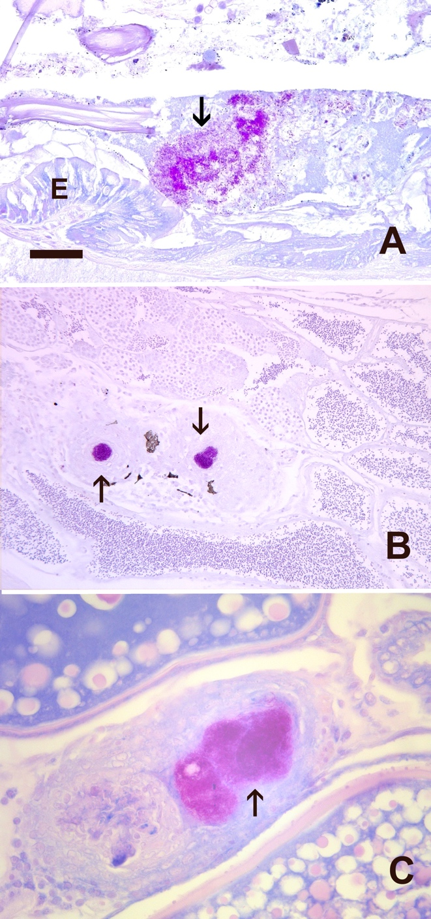

**Figure 3.1Histologic sections stained with Kinyon’s acid fast statin in zebrafish exposed to Mycobacterium**

**chelonae. Bar = 25 um. Arrow = acid fast bacteria. A. Bacteria in intestinal lumen. E = intestinal**

**epithelium. B. Testis with two granulomas with acid fast bacteria. C. Ovary with two granulomas, one**

**containing abundant acid fast bacteria.**

**3.2) Alpha Diversity**

**3.2.1)**

**3.2.2)**

**3.3) Beta Diversity**

**3.3.1)**

**3.4) Beta Dispersion**

**3.4.1) Gemma Diet**

|  |  |  |
| --- | --- | --- |
| **Bray-Curtis** | **Canberra** | **Sørensen** |
|  |  |  |

**3.4.2) Watts Diet**

|  |  |  |
| --- | --- | --- |
| **Bray-Curtis** | **Canberra** | **Sørensen** |
|  |  |  |

**3.4.3) ZIRC Diet**

|  |  |  |
| --- | --- | --- |
| **Bray-Curtis** | **Canberra** | **Sørensen** |
|  |  | **Inserting image...Inserting image...** |

**3.5) Differential Abundance**

**3.5.1) All Diets**

**3.5.2) Gemma Diet**

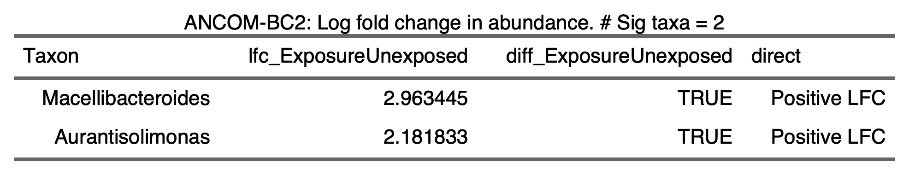

**3.5.3) Watts Diet**

**3.5.4) ZIRC Diet**

**3.5.5)**

1. **Diet Nutrition and Formulations**

**4.1.1) Proximate and elemental analysis**

